**Project Title:**

Multimodal Deepfake Detection Using Pattern Recognition Techniques

**Team members:**

Pooja N P - Working on Methodology and Algorithm

Sahana Priya G – Database Management

Ankitha R – Front end design (UI/UX)

Ankitha - Back end designing

**Abstract:**

The era in which we are presently in is highly into the tech field, With the rise of all technologies like AI, ML, DL and many, we even facing a problem without knowing, like some deepfakes or manipulated media's that falsify voice, video and even images data. Even we know that the voice of our prime minister also got morphed these days. All these leads to the significant threats to privacy, security of some data. Earlier traditional detection system such as feature extraction, image forensics, template matching and etc., they often focus on the single modality like either audio or video or an image and struggle to generalize the different types of morphing attacks. But in this project, we use advanced techniques to detect multimodal deepfake detection using pattern recognition, integrating audio, video and image analysis into a unified framework. By using unique and consistent patterns of manipulation across multiple media types, the system leverages feature extraction methods and ML classifiers to identify subtle anomalies indicative of deepfake alterations.

**Problem Statement:**

* Currently, there is no good software available that can reliably tell if a video, photo, or voice recording has been faked or manipulated.
* People can misuse deepfake technology to create fake videos or audio, which can be used to spread lies, damage someone's reputation, or commit fraud.
* This project aims to create software that can detect fake videos, photos, and voice recordings by analysing patterns across different types of media, helping people and organizations to identify fake content and stop its misuse.

**Proposed Solution:**

* The software will check videos, audio, and images together to accurately identify deepfakes by spotting unusual signs across different media types.
* Users can easily upload their media files and receive clear results indicating whether the content is real or fake.
* Pattern Recognition: It will use smart technology to detect unusual signs, like unnatural movements in faces or mismatched voices in videos. This helps identify fake content more accurately.

**Use of Vultr Services:**

* Scalable Resources: Leverage Vultur Cloud's computing power for training on diverse datasets (images, audio, videos).
* Training Detection Models: Using popular machine learning tools to build and improve our model. Vultr allows us to easily adjust our resources as our needs grow, making it simple to scale up when necessary
* **Easy Setup**: Vultr let us get our deepfake detection environment up and running without complex setup.

**Target Audience:**

* Content Creators: People and businesses that make videos and images, who want to ensure their work is real and not misused.
* Social Media Platforms: Companies that run social media sites, looking for tools to help them find and remove fake content.
* Journalists: News professionals who need to verify videos and audio before sharing to avoid spreading false information.
* Legal Professionals: Lawyers and courts that need to check if media used as evidence is genuine and not manipulated.
* General Public: Everyday people who want to verify if the videos and images they see online are real or fake.

**Feasibility Analysis:**

* Our project tries to use well-known machine learning techniques, like pattern recognition and neural networks, which are reliable and proven to work for detecting fake media.
* There are public datasets available for training our system, and cloud services that can handle the processing required.
* With proper planning, the project can be completed within a required timeframe, using available resources effectively.
* The system can be continuously improved and updated as new deepfake techniques emerge, ensuring it remains effective in the long term.

**Preliminary Diagram:**

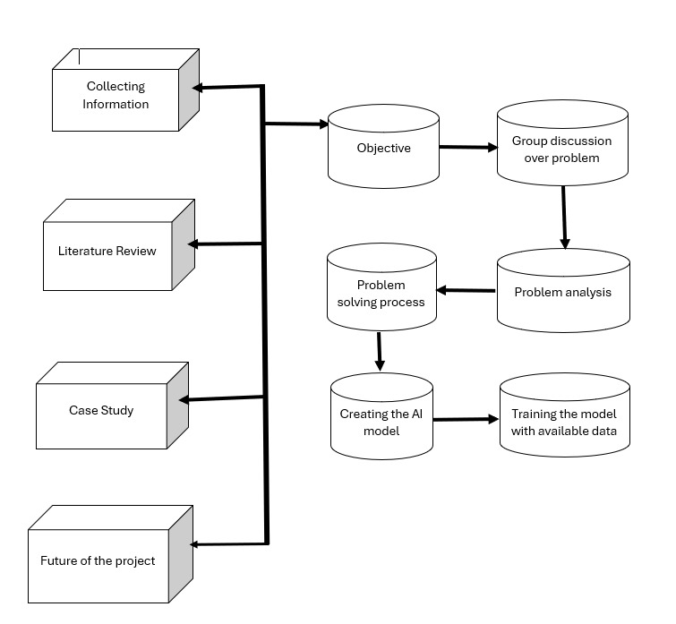

**Expected Outcome:**

Deepfake Detection Tool: Create a software program that accurately identifies fake videos, audio, and images, helping users tell the difference between real and fake content.

Easy-to-Use Interface: Design a simple and friendly interface that allows anyone, even those without technical skills, to easily upload and analyse their media files.

Trustworthy Digital Content: Improve the reliability of online media by giving people and organizations tools to check if content is real, which can help stop the spread of fake news and misinformation.